Class Specification Document
This document contains a detailed specification of classes identified during the analysis and design phase for the KriGo system. The class model represents the static structure of the system, and describes the entities, attributes, operations and relationships needed to support customers, rental agencies, administrators, financial management, notifications, reservations, and mobile applications.
The Class Specification Document includes specification of the KriGo smart car rental platform showing classes’ attributes and operations, relations between the classes and their responsibilities. The customer and rental manager class specifies how customers can register and login to the platform, search and book rentals, manage bookings and make online payments. Rental agency class specifies how agency managers can create and manage rental agencies on the platform. Administration and financial manager class specifies how administrators can manage the platform resources and users, process users’ rental requests and refunds, perform administrative tasks like generating reports and statistics on system usage, etc. Mobile services manager class specifies functionalities related to supporting mobile applications in the platform and AI and external services manager class specifies integration with external services as well as artificial intelligence components.
The chosen classes identify objects used in the system and model its structure using an object-oriented approach. Each class outlines its responsibilities and associations with other classes.
The system applies object-oriented principles like abstraction, encapsulation, inheritance, and separation of concerns. The system will be scalable, easy to maintain, and enhance with the principles applied. Lastly, the system will provide AI services, connections to external APIs, and mobile services.
The Class Diagram captures platform objects’ complete specifications at a high level. This document will help developers, stakeholders, and architects to picture the system’s design.
The class diagrams are organized into five logical packages:
- System Overview
- Administration & Moderation
- Agency Management
- Customer & Rental Management
- Mobile Application
These packages collectively form the complete domain model of the platform.

Contents
System Architecture Overview 1
Core User Hierarchy 3
Customer Management Package 4
Agency Management Package 6
Administration Package 8
Mobile Application Package 10
Service Classes 12

Figures
Figure 1 - System Overview Class Diagram 2
Figure 2 - User Hierarchy 3
Figure 3 - Customer/Rental Management Class Diagram 4
Figure 4 - Agency Management Class Diagram 6
Figure 5 - Administration & Financial Management Class Diagram 8
Figure 6 - Mobile Application Class Diagram 10

System Architecture Overview
The overall class model is organized around four primary actor groups:
- Customers
- Agency Personnel
- Administrators
- Financial Officers
The system uses several supporting services:
- AI Recommendation Service
- AI Analytics Service
- Payment Gateway
- Notification Service
- Maps Service
The following diagrams represent the system structure:
- Customer Rental Management Diagram
- Mobile Application Diagram
- Agency Management Diagram
- Administration Diagram
- System Overview Diagram

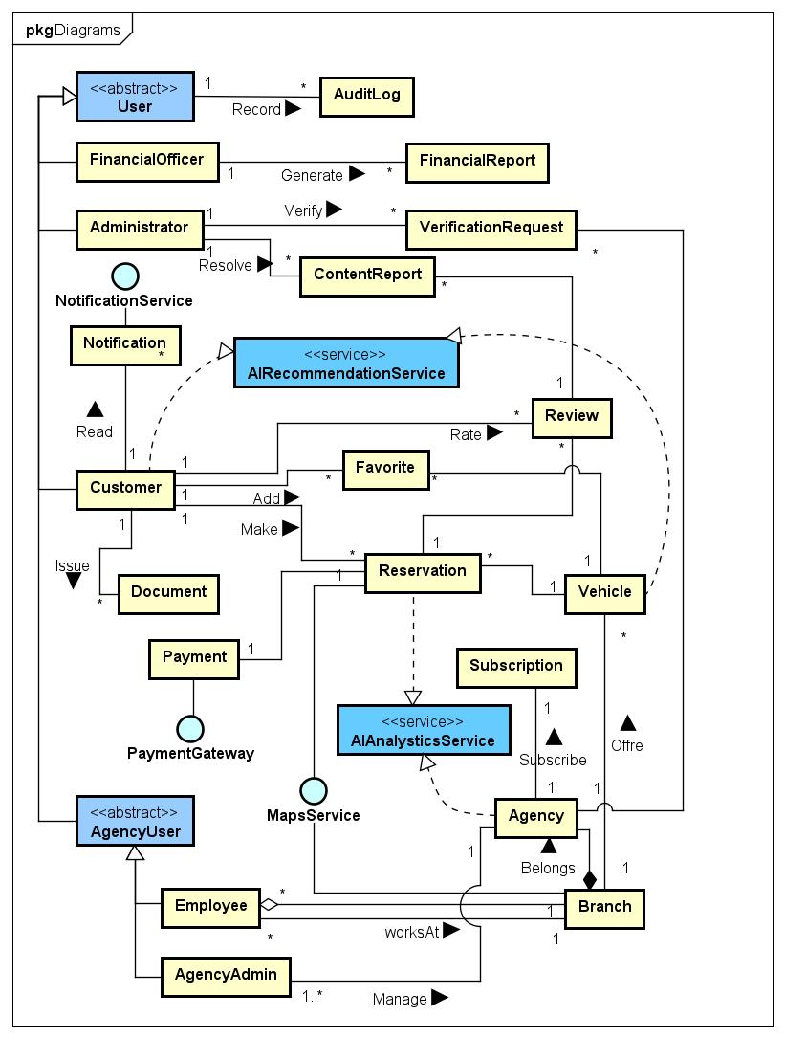
Figure 1 - System Overview Class Diagram

Core User Hierarchy
User (Abstract)
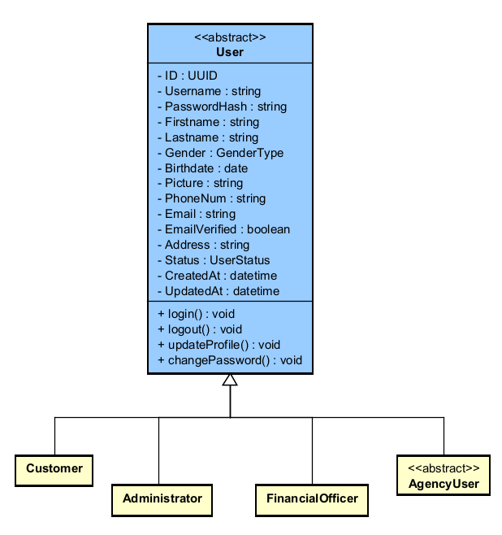
The User class is an abstract base class representing all registered users in the car rental system. It stores general personal data, authentication credentials, account status, and audit timestamps common to all user types such as customers, administrators, financial officers, and agency personnel. It also provides basic features such as user authentication, profile management and password change. The module acts as a base for all other user roles in the system.
Figure 2 - User Hierarchy

Customer Management Package
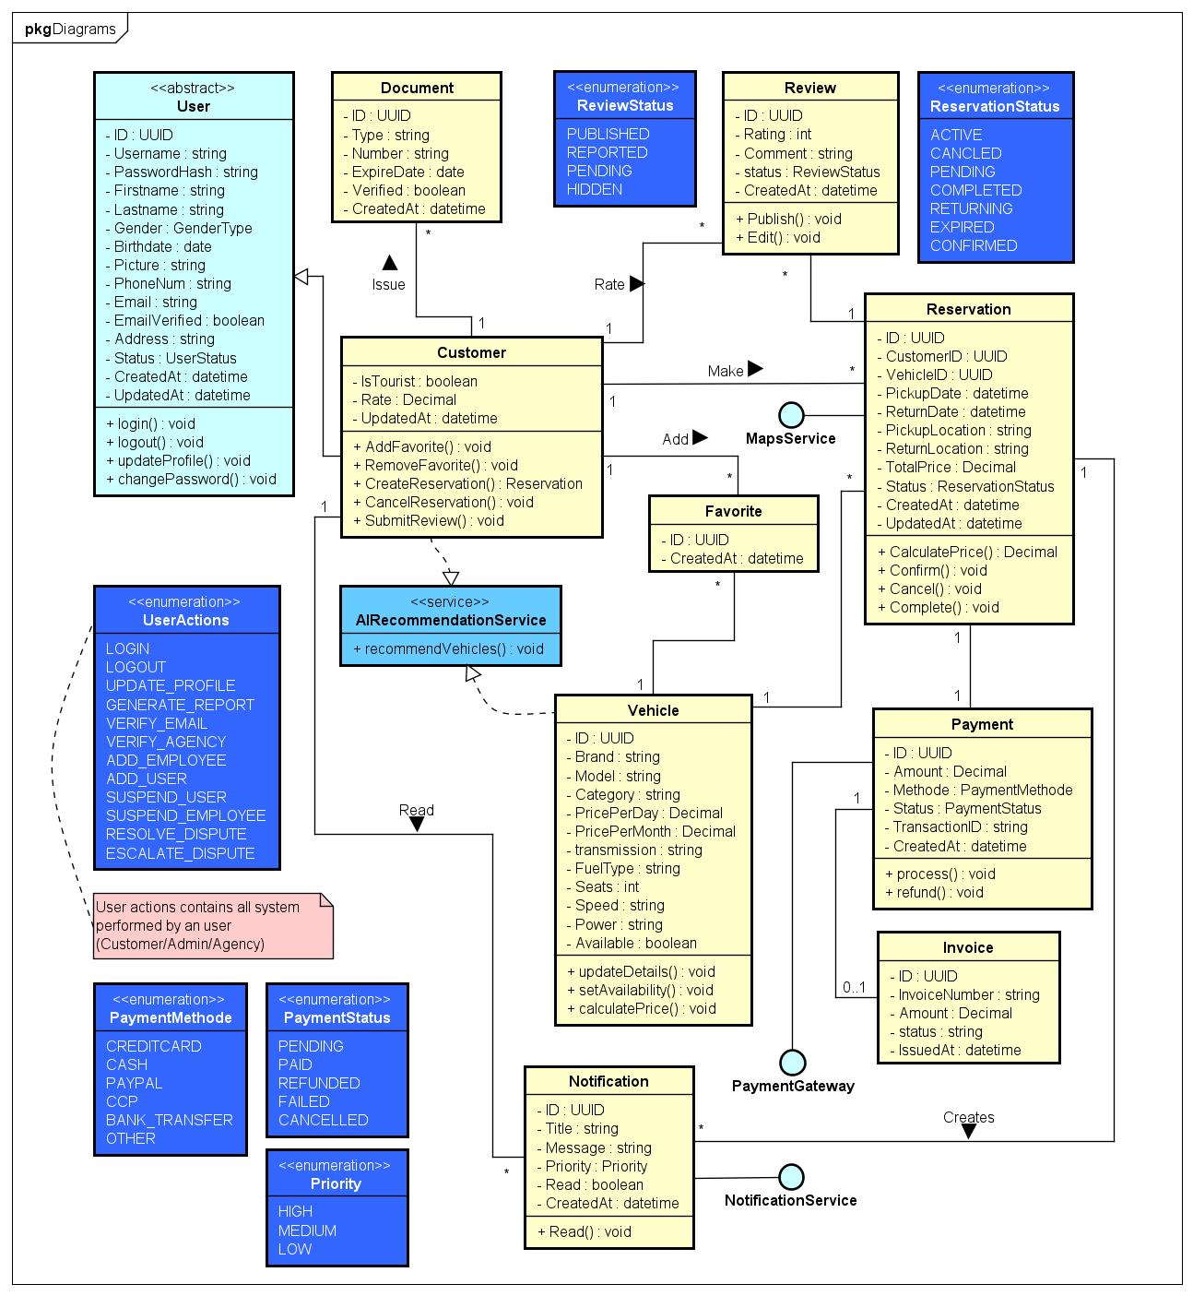
The Customer/Rental Management Class Diagram shows the basic business processes in the car rental system, including customer account management, vehicle reservation, payment, reviews, favorites, notifications, and AI-based recommendations. The main entity is the Customer class, which allows users to manage their personal documents, make and cancel reservations, write reviews, and keep favorite vehicles. The Reservation class manages the entire rental lifecycle and the Vehicle class contains the vehicle specifications, pricing and availability information. Supporting classes Payment, Invoice and Notification are responsible for financial transactions and communication with customers.
Figure 3 - Customer/Rental Management Class Diagram
Customer
The Customer class defines users that have registered with the car rental service and utilize the services of the company for searching vehicles, creating reservations, managing their favorite vehicles and submitting reviews. The customer class extends the User abstract base class by adding attributes and methods specific to customers and represents the primary class for the system's management of the customers rental experiences.
Vehicle
Check if a rental vehicle available in the system. Contains data including make, model, type/category, rate, specs and availability; includes functions to manage vehicle details and rental rates.
Reservation
Manages the reservation process for the vehicle booking. Stores reservation data such as customer, vehicle, "pick up" & "drop off" information, total cost, status of reservation, as well as other information. Supports reservation confirmation, cancellation & completion.
Payment
Handles reservation-related financial transactions. It records payment amount, method(s), transaction details & payment status as well as provides payment processing & refund operations.
Invoice
Document generated after a successful payment is referred to as the Billing Document. This is an invoice that contains information about the invoice number, invoice amount, invoice status & date of the invoice for the purpose of tracking and reporting on financial transactions.
Review
Provides the customer with the ability to rate & provide feedback on their completed reservation. Stores review score(s), customer comments, "review" status & publication date so the customer can evaluate the service received & the quality of the service.
Favorite
Saved vehicles represent the customers who are able to retrieve their vehicles at a later date. Maintains the customer-vehicle relationship in order to provide a better user-experience & to facilitate the recommendation process.
Document
Stores customer identification & verification documents that are required to rent a vehicle. The identification document type, number, verification status & date of creation, are stored for the purpose of validating the customer's identity.
Notification
Manages messages that are sent to users for "reservation" confirmations, payment transactions, account-related updates & "system" events. Stores message content, priority, read-status, & date of message creation in order to "facilitate" communications between the users and the company.

Agency Management Package
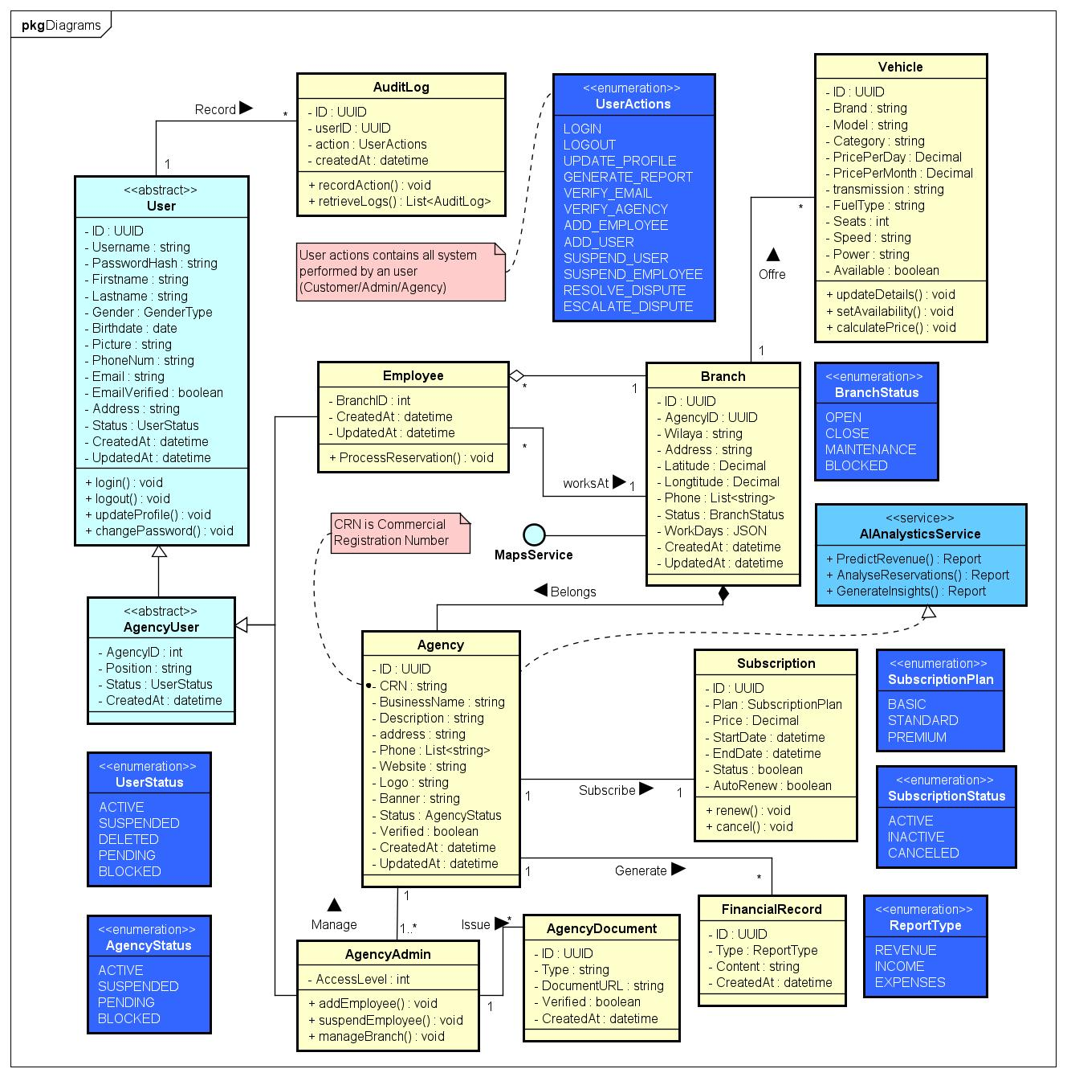
The class diagram of agency management represents the structure and operations of the rental agencies in the system. Define Agency, Branch, Agency Admin and Employee relationships. Managing subscriptions, financial records and agency verification documents. The diagram also leverages external services like MapsService and AIAnalyticsService to assist in location management and business analytics.
Figure 4 - Agency Management Class Diagram

Agency
is an agency that is registered on the platform and acts as a “master” entity to govern all other branches, employees, and resource activities associated with the agency. The agency holds a record of business information, verification status, subscription information, and operational information related to the agency.
Branch
is a location that an agency operates from, and stores location-related information, including, but not limited to contact information, hours of operation, and the status of the location. The agency location acts as a place from which the agency manager and employees can manage vehicles and employees.
Agency User (Abstract)
is an abstract User class that is extended by Agency Personnel, and describes common characteristics and attributes that all employees of an agency have in common. The Agency Personnel class will serve as the base class for Agency Personnel Roles such as Agency Administrator and Agency Employee.
Agency Admin
represents administrative users who are responsible for overseeing the operations of the agency. This includes providing functionality to manage the branches and employees of the agency, manage agency settings, and manage agency operations within a rental agency.
Employee
are employees who work at an agency location. Employees perform day-to-day activities associated with the rental, including processing reservations; assisting customers with their needs; and managing the primary functions of the agency.
Agency Document
contains all documents of record pertaining to the legal and verification status of the agency. This includes the document type, status of verification, the date the document was created, and supporting documentation associated with the verification process.
Subscription
manages agency subscription plans and billing of the subscription fees. The subscription details include subscription plan type, price, length of the subscription plan, subscription plan status, and subscription plan renewal settings to determine the agency’s access to services on the platform.
Financial Record
Holds all financial-related data associated with agency operations (i.e., revenues, expenses) and financial reports. This component supports financial tracking (e.g., revenue & expense), reporting, and analyzing business performance.

Administration Package
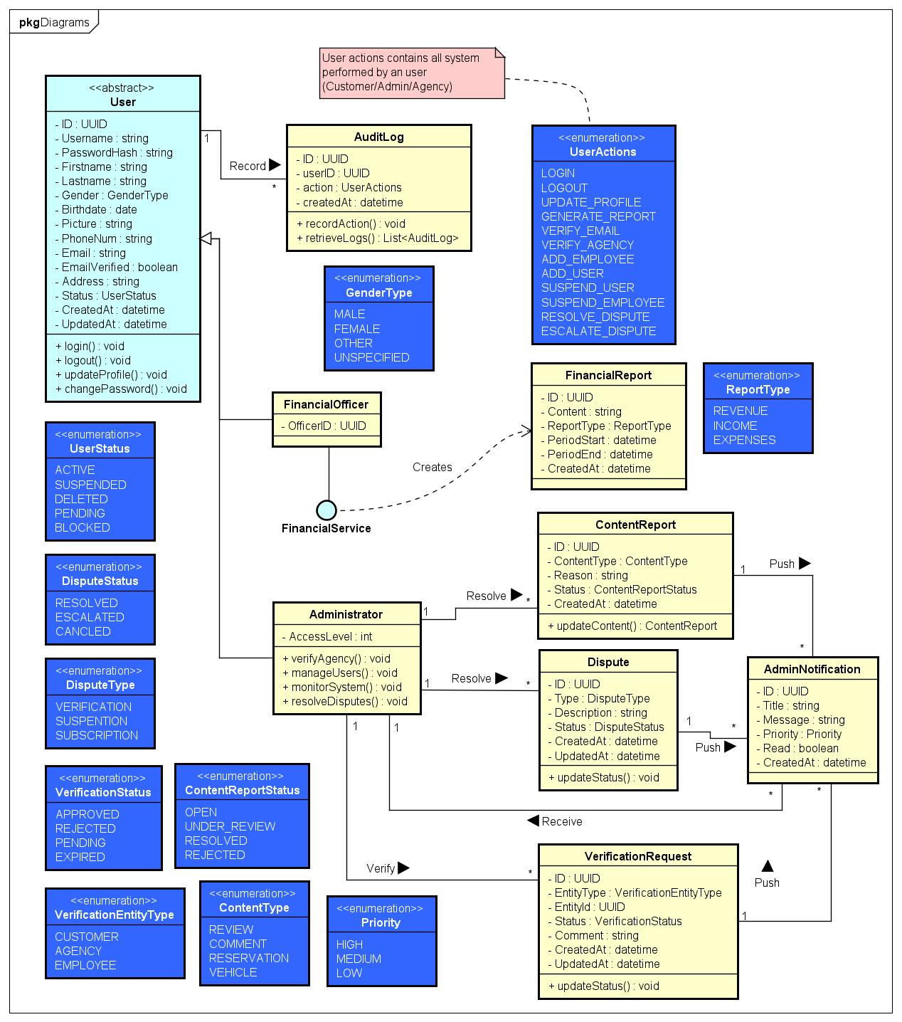
The class diagram of Administration and Financial Management presents the administrative, moderation, and financial monitoring functions of the system. It describes the roles of Administrator and Financial Officer users when handling verification requests, disputes, content reports, financial reports and system notifications. The diagram also shows auditing and financial services for system monitoring, reporting, and administrative decision-making.
Figure 5 - Administration & Financial Management Class Diagram

Administrator
contains an administrator who manages the entire system, as well as operations on the platform itself; the administrator will be responsible for managing users, verifying agencies, resolving disputes, monitoring the system, and handling any requests related to doing these administrative tasks so that the platform is secure and runs properly.
Financial Officer
represents a functional administrator position that is responsible for financial management. This position interacts with the financial service to generate financial reports, track and monitor revenue and assess the overall financial activity of the agency.
Financial Report
contains all the financial analytical reports that are produced within the system. The data stored within this table includes report types, reporting periods and data used by the agency to track revenue, analyze expenditures and make financial decisions.
Verification Request
represents a request for entity verification within the system. Each request will contain a target entity, as well as the status of the entity's verification (i.e. pending, complete, failed, etc.) and any related comments and timestamps. This allows the System Administrators to properly approve or deny verification requests.
Dispute
contains disputes or issues raised by users, agencies or employees. The table maintains all aspects of the dispute, as well as the current status and history of updates in relation to each dispute allowing the System Administrator to review and resolve disputes effectively.
Content Report
reports received about inappropriate or problematic content on the platform, such as reviews, comments, reservations or vehicles. The table will track the details of the content that was reported, the reason for reporting, and the status of the moderation of the content that was reported.
Admin Notification
contains notifications that are created for administrators when there is an important event in the system, such as a dispute, a request to verify an agency, or a report about inappropriate content; the class also keeps track of all the details regarding each notification, including when the notification was sent, if it has been read, and its level of priority.
Audit Log
contains a record of all user activity and other actions taken on the system throughout the platform; it provides a history of what actions were taken, who took them, and when they happened, so users are accountable for their actions and to enable security auditing.

Mobile Application Package
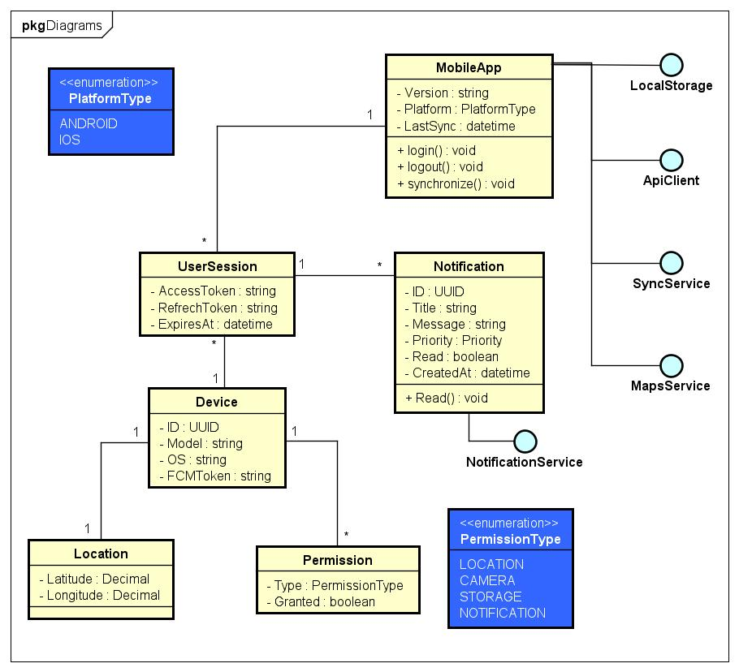
The class diagram of Mobile Application models the architecture of mobile client of the car rental system. It takes care of user authentication, local storage, device permissions, and push notifications. It describes the associations between the classes MobileApp, UserSession, Device, Notification, and Permission. To enable communication , synchronization , and mobile - specific features , the diagram also includes external interfaces , Api Client , Sync Service , MapsService , Notification Service , and Local Storage .
Figure 6 - Mobile Application Class Diagram

MobileApp
contains the mobile application that customers and agencies use to interact with the car rental; it will handle user authentication, synchronizing of users with the server, updating, and other operations with outside services.
UserSession
holds an authenticated session for a user of the mobile application; it includes information about a user's session token, device, time before it expires, and will validate, renew, and terminate a user's session.
Device
holds a record of the device used by customers to access the mobile application; it will store the device's ID and OS and model, and any notification tokens used to authenticate the user to the device via push notifications.
Location
Location objects represent places and provide geographic information about these locations for the mobile application. They have information about the latitude and longitude as well as an address. Location Services uses this information to provide location-based services (such as navigation) and to search for vehicles near your location.
Permission
The Permission object manages permissions granted by the user to the mobile app (such as access to the location, access to the camera, access to storage, and notifications), which enables the app to securely access features of the device.

Service Classes
AI Recommendation Service
provides recommendations for vehicles that are based on the user’s specific preferences and location to the user, based on their previous rental history and previous searches. It uses artificial intelligence-based algorithms to improve the selection of vehicles for the user.
AI Analytics Service
provides analytical and predictive insights about the agency’s or administrator’s operations and/or administrative issues based on operational and financial metrics and data collected. This class will provide reports, identify trends, and help users access and use the data they need to make decisions.
Maps Service
provides a set of location-related services, including geolocate, calculate distance, plan a route to a location or provide an address to find a vehicle or navigate between branches.
Notification Service
manages the way that notifications are sent to users of the mobile application via different communication methods (e.g., push notifications, email, SMS), so that users can receive notifications in a timely manner.
Payment Gateway
interface manages payment transactions that occur on the mobile application. The Payment Gateway will facilitate the payment process through external payment providers by processing payments, validating transactions, and processing refunds.
Api Client
interface is responsible for managing the communication between the mobile application and the backend services. This interface contains methods for sending requests, getting responses, and managing the remote interaction with an API.
Local Storage
The Local Storage interface provides functionality to manage the storage and retrieval of data on a user's device. It includes functionality for applying some form of caching, offline functionality, and local persistence of the application's data.
Sync Service
The Sync Service interface is responsible for coordinating the synchronization of data between the mobile application and the backend. The Sync Service helps provide a consistent data state by synchronizing local changes back up to the server and pulling down any updates/changes that were made by other parties on the server.

